How to move the method from
one platform to another platform

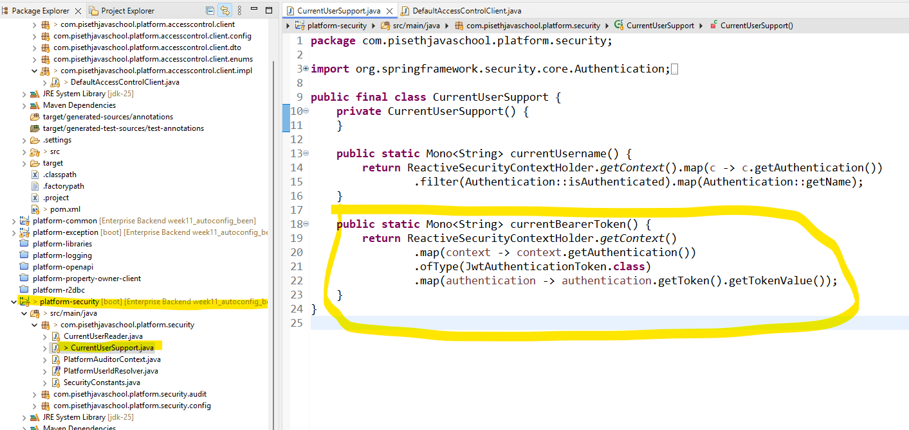

We move the currentBearerToken to the Security platform.
>> mvn clean install to create
- Dependency:

<dependency>
<groupId>com.pisethjavaschool.platform</groupId>
<artifactId>platform-security</artifactId>
<version>${project.version}</version>
</dependency>

Go to where we want to remove the code: but first we need to add the library first to that platform.

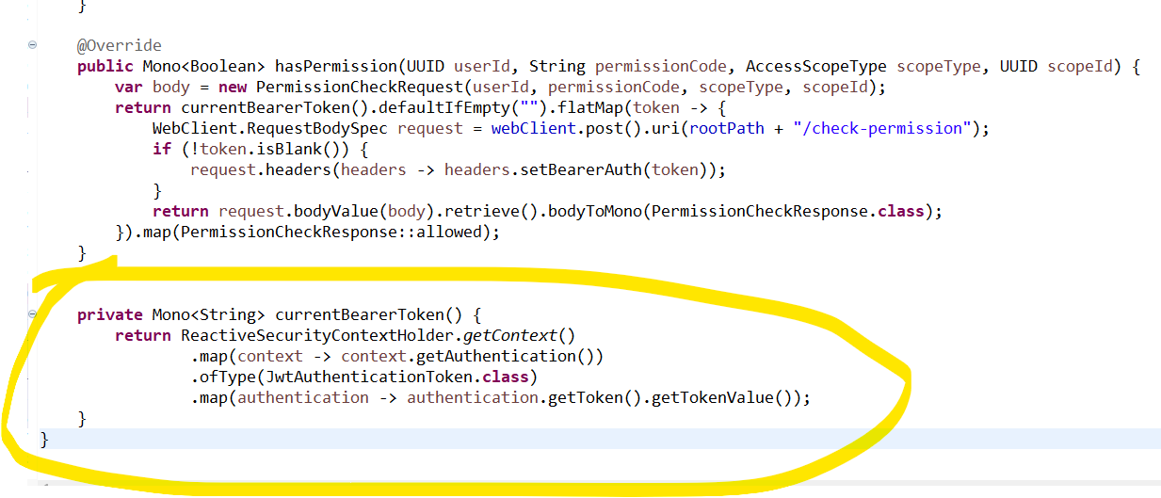

Then we remove this function : currentBearerToken

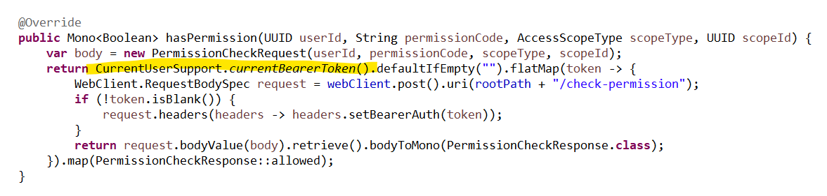

យើងធ្វើការ ហៅ function នឹងមកប្រើដោយធ្វើការ ឈ្មោះ class then . method នឹងតាមក្រោយ។

